**DAILY ONLINE ACTIVITIES SUMMARY**

|  |  |  |  |  |  |  |  |
| --- | --- | --- | --- | --- | --- | --- | --- |
| **Date:** | **27/05/2020** | | | | **Name:** | **Sannidhi P** | |
| **Sem & Sec** | **8th- B** | | | | **USN:** | **4AL16CS084** | |
| **Online Test Summary** | | | | | | | |
| **Subject** | | **IOT** | | | | | |
| **Max. Marks** | | **30** | | **Score** | | **23** | |
| **Certification Course Summary** | | | | | | | |
| **Course** | **JAVASCRIPT Tutorial** | | | | | | |
| **platform** | | | **SOLOLEARN** | **Duration** | | | **2 hours** |
| **Coding Challenges** | | | | | | | |
| **Problem Statement:**  **1)** Java program to validate the identifiers using Regular Expression. | | | | | | | |
| **Status: Executed** | | | | | | | |
| **Uploaded the report in Github** | | | | **Yes** | | | |
| **If yes Repository name** | | | | **sannidhi1** | | | |
| **Uploaded the report in slack** | | | | **Yes** | | | |

Online Test Details:

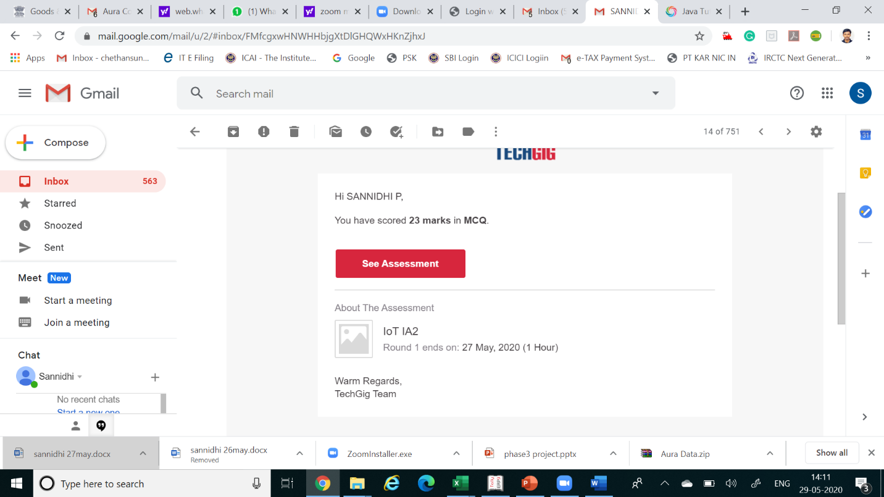

Certification:

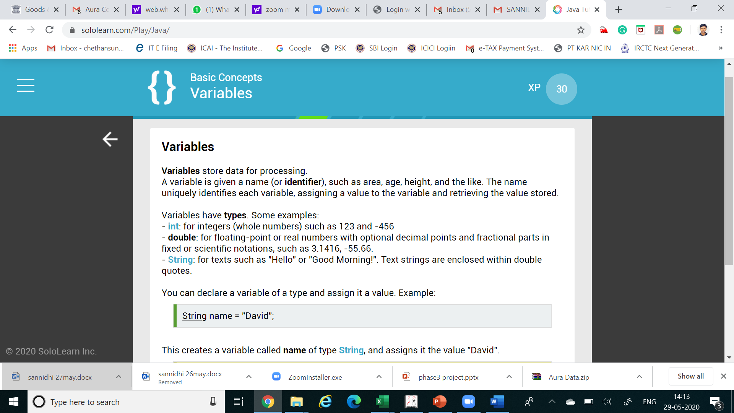

Coding Challenges Details:

// Java program to validate the identifiers using Regular Expression.

import java.util.regex.*;

class GFG {

// Function to validate the identifier.

public static boolean

isValidIdentifier(String identifier)

{

// Regex to check valid identifier.

String regex = "^([a-zA-Z_$][a-zA-Z\\d_$]*)$";

// Compile the ReGex

Pattern p = Pattern.compile(regex);

// If the identifier is empty

// return false

if (identifier == null) {

return false;

}

// Pattern class contains matcher() method

// to find matching between given identifier

// and regular expression.

Matcher m = p.matcher(identifier);

// Return if the identifier

// matched the ReGex

return m.matches();

}

// Driver Code.

public static void main(String args[])

{

// Test Case 1:

String str1 = "$valid123";

System.out.println(isValidIdentifier(str1));

// Test Case 2:

String str2 = "$hell ks123";

System.out.println(isValidIdentifier(str2));

// Test Case 3:

String str3 = "1hello$";

System.out.println(isValidIdentifier(str3));

}

}